To register for our summer playground program please visit our website at [www.harp-online.org](http://www.harp-online.org). Space is limited. If you have questions, please contact Rick Kerns at [info@harp-online.org](mailto:info@harp-online.org) or call 717-993-2255.

Our mailing address is PO Box 959 Stewartstown, PA 17363

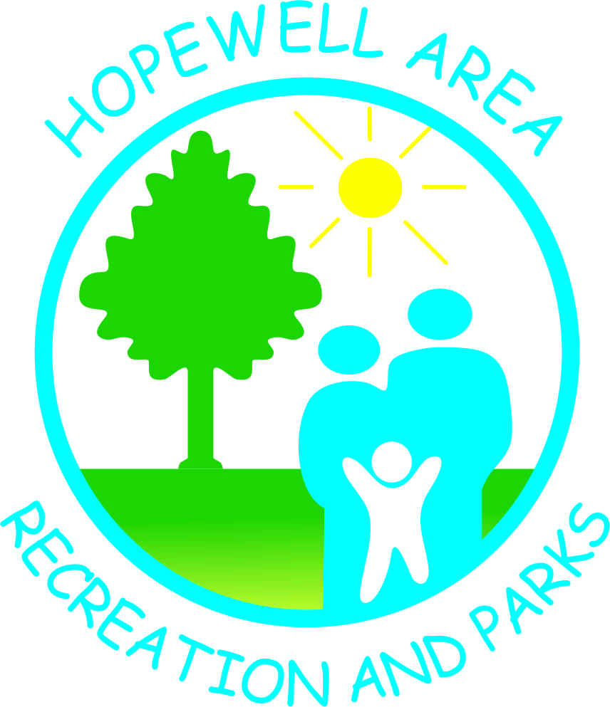

| **2023 HARP SUMMER Playground THEMES & DESCRIPTIONS**  Week 1 – **Team Sports Week**- COMPETE in various team sports throughout the week such as Tennis baseball, dodgeball, basketball, wiffleball, kickball, and others.  Week 2 – **NERF Wars week**- Participate in various Nerf battle games such as dodgedart, zombies vs. humans AND Freezedart. bring your favorite NERF blaster everyday this week. harp will supply all the darts.  Week 3 – **Unusual Sports Week**- Take a break from the classic sports we all know and join us for some obscure sports. also Work with your group to create a new sport and try it out this week!  Week 4 – **Tournament Week-** PARTICIPANTS will be split into two teams for the week and compete in various tournaments to earn their team points. all participants will earn a prize at the end of the week based on the amount of points their team earned.  Week 5 – **Holiday Celebration**- CELEBRATE Multiple holidays enjoyed once a year all in one week! Activities will include an Easter Egg Hunt, Halloween Costume Contest, and holiday gift exchange.  Week 6 – **Summer Playground Olympics**- COMPETE in various individual events throughout the week and attend our medal ceremony at the end of the week for everyone.  Week 7 – **Flashback Forever Week**- wear your favorite retro outfit to camp this week and play games that your parents enjoyed as a kid such as tag, hide & seek, and hopscotch.  Week 8 – **Figure it out week**- CREATE a boat out of cardboard and duct tape that can make it across the pool without sinking. compete in a lego building competition and other various challenges that will take your creativity to the next level.  Week 9 –**Who’s Got talent Week**- DISPLAY your hidden talents in our end of summer talent show on Friday, August 5th. There will also be a couple of themed show and tells this week for you to particpate in.  Week 10 – **Wet & Wild Week**- Bring your favorite water soaker for various activities to keep us all cool through the dog days of summer. |
| --- |
| **Week 1- June 5th-9th Week 6- July 10th-14th**  **Week 2- June 12th-16th Week 7- July 17th-21st**  **Week 3- June 19th-23rd Week 8- July 24th-28th**  **Week 4- June 26th-30th Week 9- July 31st-Aug. 4th**  **Week 5- July 3rd-7th** **Week 10- Aug. 7th-11th** |